SCHOOL OF COMPUTING
PHENIKAA UNIVERSITY
o0o

PROJECT REPORT
COURSE: SOFTWARE ARCHITECTURE

PROJECT TITLE: CINEMA MANAGEMENT
Group 14
Student Name | ID
Nguyen Que Bac | 23010574

Course Instructor: Vu Quang Dung
Ha Noi, February 5, 2026

Contents
1. Cover Page & Info 3
2. Executive Summary 3
3. Architectural Design & Implementation 3
3.1 C4 Model 3
3.2 Technical Stack and Data Model 11
3.3 Overall Architecture – Layered Monolith 12
3.4 Detailed Architecture 14

Cover Page & Info
- Project Title: Cinema Management
- Assigned Tasks: C4 model, Detailed Architecture
- Course Name: Software Architecture
- Student Info: [Nguyen Que Bac], [23010574]
- Date: February 5, 2026

Executive Summary
My assigned task in this project was to design and document the system architecture, with a focus on the C4 Model and the detailed architecture of the Cinema Management System. The C4 Model was used to describe the system at multiple levels, including system context, containers, components, and code, providing a clear and structured view of how the system is organized and how its parts interact.
In addition, the detailed architecture section explains the layered monolithic design based on the MVC pattern, highlighting the responsibilities of the presentation, business, and database layers. Key workflows such as movie booking and payment simulation are also described to demonstrate how architectural decisions support core functionalities, data consistency, and maintainability.
Overall, this work helps clarify the system design and provides a solid architectural foundation for development and future maintenance.

Architectural Design & Implementation

C4 Model
System Context Diagram (C4 Model – Level 1)
The C4 Model (Level 1: System Context) illustrates the boundary of the Cinema Management System.
Actors:
- Users / Customers: Browse movies, select seats, and book tickets via a web browser.
- Administrators: Manage movies, showtimes, cinema rooms, seats, and view reports.
Interactions:
- All interactions occur via standard HTTP requests and responses.
- The system communicates with a centralized relational database to store and retrieve data related to users, movies, showtimes, bookings, and reports.
External Systems:
None required for core functionality. The design remains simple and cohesive, focusing on reliable cinema operation management.
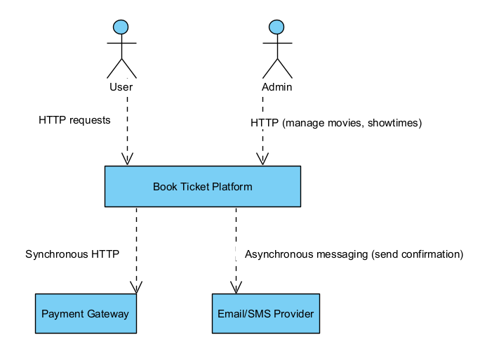
Figure 1: System Context Diagram

Container Diagram (C4 Model – Level 2)
The container diagram provides a closer look at the main components of the system:
Web Browser (User Interface):
- Displays HTML pages rendered via Blade templates.
- Submits forms for booking, account management, and administrative tasks.
Laravel Application (Monolithic Backend):
- Controllers: Handle HTTP requests and coordinate application logic.
- Models / Eloquent ORM: Interact with the database and enforce data relationships.
- Views / Blade Templates: Render dynamic HTML pages for users and administrators.
- Business Logic: Seat availability checks, booking processing, report generation.
MySQL Database:
- Stores persistent data for users, movies, showtimes, cinema rooms, seats, bookings, and tickets.
- Ensures data consistency and supports transaction management for concurrent booking requests.
Payment Simulation (Internal Component / Mock Service):
- Role: Provides a simulated payment process for testing and demonstration purposes, without connecting to an actual external gateway.
- Responsibilities:
  - Mimics the behavior of a real payment gateway (request, validation, response).
  - Returns predefined outcomes (success/failure) to allow the booking workflow to be tested end-to-end.
  - Ensures that the system logic for handling payments, confirmations, and error cases can be verified.
- Interactions:
  - The Laravel Application sends a “payment request” to the simulated service when a user confirms a booking.
  - The simulation responds with a mock transaction status.
  - The result is stored in the MySQL Database for consistency and reporting, just like a real transaction.
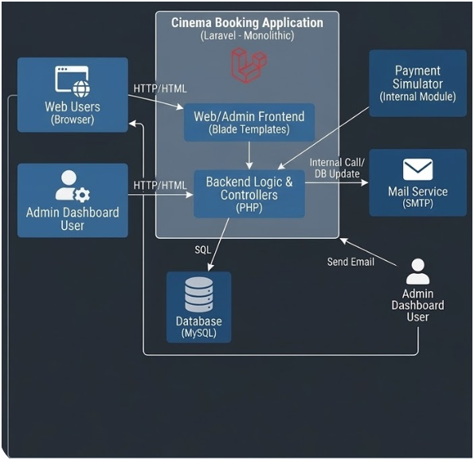
Figure 2: Container Diagram

Component Diagram (C4 Model – Level 3)
🔹 Web Browser (UI Container)
Components:
- HTML Renderer: Displays dynamic pages generated by Blade templates.
- Form Handler: Submits booking forms, login forms, and administrative actions.
- Session Manager: Maintains user sessions and cookies for authentication.
- Request Dispatcher: Sends HTTP requests (GET/POST) to the backend API.
Interactions: Users interact with the Web Browser, which sends requests to the API layer of the Laravel Application and renders responses (HTML or JSON).
🔹 MySQL Database (Data Container)
Components:
- User Table: Stores user accounts and authentication data.
- Movie Table: Contains movie details (title, genre, duration).
- Showtime Table: Stores showtime schedules linked to cinema rooms.
- Seat Table: Defines seat layout and availability.
- Booking Table: Records booking transactions.
- BookingSeat Table: Maps seats to bookings.
- Report Data: Aggregated data for statistical reporting.
Interactions: Models in Laravel Application query and update these tables through Eloquent ORM, ensuring transactional integrity.
🔹 Payment Simulation (External Container)
Components:
- Request Handler: Receives simulated payment requests from the backend.
- Validation Module: Mimics card/e-wallet validation.
- Transaction Processor: Returns mock transaction results (success/failure).
- Response Generator: Sends results back to the Laravel Application.
Interactions: The BookingService calls the Payment Simulation module during booking confirmation. The module responds with simulated outcomes, which are stored in the database for consistency.
🔹 Laravel Application (Backend Container)
Within the Laravel Application (Monolithic Backend) container, the system is divided into several core components. Each component has a specific responsibility and interacts with others to ensure smooth processing of business operations and communication with external containers such as the Web Browser (UI) and the Database.
Main Components
- API Layer
  - Acts as the entry point for all HTTP requests coming from the Web Browser.
  - Routes requests to the appropriate controllers.
  - Returns responses in either JSON (for API endpoints) or HTML (for web pages).
- Controllers
  - BookingController: Manages the booking workflow, including seat selection and validation.
  - MovieController: Handles movie listings and details.
  - AdminController: Provides administrative functions such as user management, showtime management, and reporting.
  - Controllers coordinate with services to execute business logic.
- Models / Eloquent ORM
  - Represent system entities such as User, Movie, Showtime, Booking, and Seat.
  - Manage database queries and relationships using Laravel’s Eloquent ORM.
  - Ensure data consistency and integrity in the MySQL database.
- Payment Simulation Module
  - Simulates the payment process for testing and demonstration purposes.
  - Returns mock transaction results (success/failure) to validate the booking workflow.
  - Allows the system to test payment integration without connecting to a real gateway.
- Views / Blade Templates
  - Render dynamic HTML pages based on data provided by controllers.
  - Present information such as movie lists, booking confirmations, and reports to users and administrators.
  - Serve as the bridge between backend logic and the Web Browser (UI).

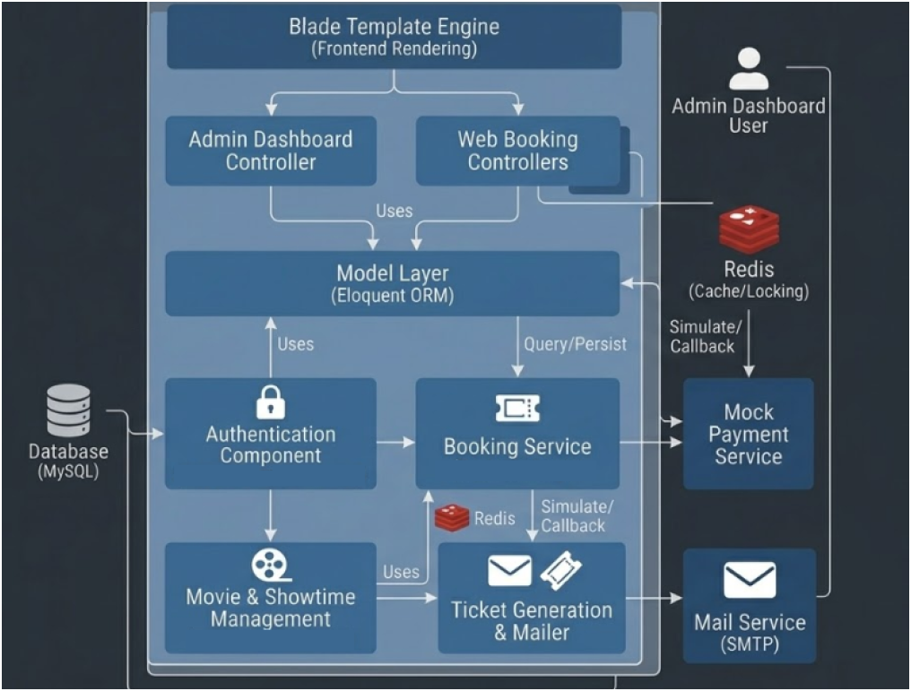
Figure 3: Backend Component Diagram
Code level (C4 Model – Level 4)
🔹Example: Booking Flow
BookingController
- index() → Show booking form.
- store(Request $request) → Validate input, call Booking model to create a new booking, update seat status.
- confirm($id) → Retrieve booking details and pass them to the view.
Booking (Model – Eloquent ORM)
- fillable = ['user_id', 'showtime_id', 'seat_id', 'status'] → Defines attributes for mass assignment.
- user() → Relationship with User model.
- showtime() → Relationship with Showtime model.
- seat() → Relationship with Seat model.
Seat (Model – Eloquent ORM)
- fillable = ['room_id', 'number', 'status'].
- isAvailable() → Check if seat is free.
- book() → Update seat status to reserved.
Blade Views
- booking/index.blade.php → Displays booking form.
- booking/confirm.blade.php → Shows booking confirmation.
🔹 Example: Movie Flow
MovieController
- index() → List all movies.
- show($id) → Show movie details.
Movie (Model – Eloquent ORM)
- fillable = ['title', 'genre', 'duration'].
- showtimes() → Relationship with Showtime model.
Blade Views
- movies/index.blade.php → Displays movie list.
- movies/show.blade.php → Displays movie details.
🔹Example: Admin Flow
AdminController
- index() → Admin dashboard.
- users() → Manage users.
- reports() → Generate reports from Booking model.
User (Model – Eloquent ORM)
- fillable = ['name', 'email', 'password'].
- bookings() → Relationship with Booking model.
Blade Views
- admin/index.blade.php → Dashboard view.
- admin/reports.blade.php → Report view.
🔹 Payment Simulation (MVC Integration)
Since you don’t use a service layer, the Payment Simulation can be integrated directly in the BookingController:
- processPayment($bookingId) → Calls a helper or a simple class PaymentSimulation that returns mock results.
- Result is stored in the Booking model and displayed via Blade view.

Technical Stack and Data Model
- Server Framework: Laravel (PHP), a robust MVC-based web framework that provides structured routing, authentication, and database abstraction through Eloquent ORM, enabling rapid development and maintainable code organization.
- Client: HTML, CSS, and JavaScript, used to build a responsive web interface for users and administrators to interact with the system through standard HTTP requests.
- Database: MySQL (Relational Database), used to persist core system data including users, movies, showtimes, cinema rooms, seats, bookings, and ticket transactions.
- Data Model: The system employs a centralized relational data model designed to ensure data consistency and integrity. Key entities include User, Movie, Showtime, CinemaRoom, Seat, Booking, and Ticket. Relationships between entities are enforced through foreign keys and managed using Laravel’s Eloquent ORM.

Overall Architecture – Layered Monolith
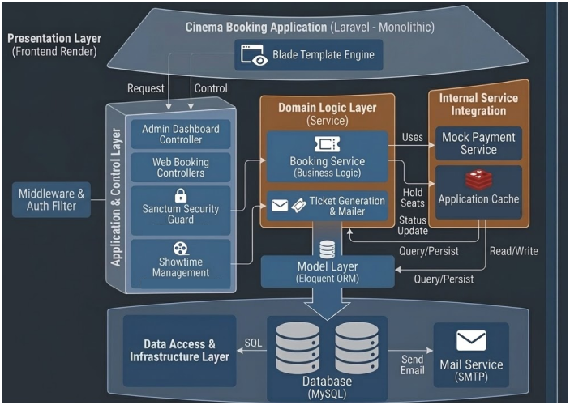
Figure 4: Architectural model
The provided diagram illustrates a layered architectural model for a Cinema Booking Application built on a Laravel Monolithic framework. This architecture organizes the system into distinctive functional layers, ensuring separation of concerns while maintaining a single, unified application codebase.
The model is composed of four primary layers, structured as follows:
1. Presentation Layer (Frontend Render)
Positioned at the apex, this layer is responsible for rendering the user interface and handling user interactions from both customers and administrators.
- Key Component: Blade Template Engine. Laravel utilizes Blade to perform server-side rendering of dynamic HTML files, which are then served to the user's browser. This layer is shown initiating dynamic Requests down the stack while maintaining a direct Control link with the application logic below.
2. Application & Control Layer
This layer functions as the orchestrator of the application, receiving HTTP requests and directing the flow of logic.
- Coordination (Middleware & Auth Filter): Incoming requests are first validated and filtered through a Middleware layer to enforce security and access controls.
- Controllers: The application is split into specialized controllers, including the Admin Dashboard Controller (managing administrative tasks) and Web Booking Controllers (handling the customer-facing booking flow).
- Security & Management: This layer integrates the Sanctum Security Guard for API token authentication and Showtime Management services (leveraging Laravel Breeze/Jetstream) to oversee scheduling and user access.
3. Domain Logic Layer (Service)
This layer contains all the core, centralized business logic for the booking operations.
- Core Services: The Booking Service (Business Logic) is the primary component here, responsible for critical tasks such as:
  - Validating seat availability.
  - Managing the booking lifecycle and transaction status.
  - Initiating internal actions like Hold Seats (connecting to the Application Cache in the Internal Service Integration column).
- Associated Services: The Ticket Generation & Mailer service handles the creation of tickets (including QR codes) and sends confirmation messages.
4. Data Access & Infrastructure Layer
At the base, this layer manages persistent data storage and fundamental system infrastructure.
- Database: A relational Database (MySQL) is depicted as the master repository for all persistent data (Users, Movies, Showtimes, Seats, Bookings).
- Model Layer: The application utilizes an Eloquent Model Layer (ORM) to abstract all database interactions, allowing for clean, object-oriented data access.
- Mail Service: A specialized Mail Service (SMTP) is shown, providing the external functionality to deliver emails triggered by the Ticket Generation service.

Detailed Architecture
The detailed architecture of the Cinema Management System illustrates how the system’s core components interact to fulfill business operations, including movie browsing, seat selection, booking, and administrative reporting.
Core Components
- Web Browser / Client
  - Users and administrators interact with the system through a web browser.
  - Requests are sent via HTTP (GET or POST) to the Laravel backend.
  - Pages are rendered using Blade templates, showing dynamic content such as movie lists, seat availability, and booking confirmations.
- Laravel Application (Monolithic Backend)
  - Controllers handle incoming requests and coordinate application logic.
    - BookingController: manages seat selection, booking creation,
    - MovieController: manages movie listing and details.
    - ShowtimeController: manages showtimes and seat availability.
    - AdminController: generates reports and manages users, rooms, and showtimes.
  - Models / Eloquent ORM represent entities in the database:
    - User, Movie, Showtime, Seat, Room , Booking, BookingSeet
BookingCombo
- Database (MySQL)
  - Stores all persistent data: users, movies, showtimes, cinema rooms, seats, bookings, combo items.
  - Supports transactional integrity, ensuring seat booking is atomic and preventing double booking.
  - Relationships between entities are managed via foreign keys and Eloquent ORM.
🔹 Flow 1: Movie Booking
- User Interaction
  - A user navigates to the booking page via the Web Browser (UI).
  - The interface displays available movies, showtimes, and seat layouts using Blade templates.
  - The user selects seats and optionally adds combo items (e.g., popcorn, drinks).
- Form Submission
  - The browser sends a POST request to BookingController@store.
  - Request parameters include user ID, showtime ID, selected seats, and combo items.
- Server Processing
  - BookingController validates input and checks seat availability.
  - A database transaction begins:
    - A new Booking record is created.
    - BookingSeat entries are inserted for each selected seat.
    - BookingCombo entries are recorded if applicable.
    - The total price is calculated.
  - If all steps succeed, the transaction commits; otherwise, it rolls back to prevent inconsistencies.
- Response
  - The system returns a confirmation page (Blade template) or a JSON response for API endpoints.
  - The UI updates to reflect booked seats and displays a success message.
🔹 Flow 2: Payment Processing (Simulation)
- Payment Request
  - After booking creation, the user proceeds to payment.
  - The BookingController calls the Payment Simulation Module instead of a real gateway.
- Payment Simulation
  - The module mimics a real payment gateway by validating the request and returning a mock result (success/failure).
  - No external API is involved; the simulation ensures the booking workflow can be tested end-to-end.
- Database Update
  - If the simulated payment succeeds:
    - The Booking record is updated with payment status = “confirmed.”
    - Transaction details are stored for reporting.
  - If payment fails:
    - The booking remains pending or is canceled.
- Response
  - The system returns a payment confirmation page (Blade template) or JSON response.
  - The UI reflects the payment outcome and provides feedback to the user.

